

DEPARTMENT OF ELECTRICAL AND COMPUTER ENGINEERING

**NORTH SOUTH UNIVERSITY**

**CSE311 Project Report**

Project ID: 02

Project Name: Hospital Management System (HMS)

Section: 02

Group ID: 14

Group Members:

Tamjid Islam: 2212626042

Md.Fahad Sikder: 2112091642

**Project Name: Hospital Management System (HMS)**

* **Project scope**

Our project is designed to efficiently track and manage data related to departments, employees, patients, and various services. Each entity in the system is clearly defined with attributes and relationships to ensure smooth operations and comprehensive data organization.

The **Departments** entity records essential details like department ID, name, and location, serving as the foundational structure for organizing hospital resources. Employees are categorized under the **Employees** entity, capturing comprehensive details like name, address, role, date of birth, salary, and department ID. Each employee may have multiple mobile numbers and email addresses stored in separate entities (**Employees_Mobile** and **Employees_Email**) for better contact management.

Specialized roles such as doctors, nurses, and administrators are further defined by their respective entities. **Doctors** are identified by attributes like license number and specialization, while **Nurses** have attributes specific to their shifts. **Administrators** are linked to their job responsibilities, and all these roles are tied back to the Employees entity using foreign keys.

The **Patients** entity holds detailed information about each patient, including contact information and demographic details. Patients are associated with **Appointments**, which capture details like appointment date, status, and the assigned doctor.

The infrastructure is represented by **Wards**, **Rooms**, and **Beds** entities. Wards are categorized by type, capacity, and floor, while rooms and beds track occupancy and availability. Beds are directly associated with patients, ensuring real-time updates on their status.

For medical services, the system includes **Lab Tests**, **Prescriptions**, and **Treatments**. Each lab test is uniquely identified and tied to the patient, while prescriptions and treatments document interactions between patients and doctors, along with detailed notes and dates. The **Medicine** entity tracks inventory details, including name, quantity, price, and expiry date, ensuring the timely availability of medical supplies.

Financial operations are managed through the **Billing** and **Insurance** entities. Billing records the total amount, payment status, and date, while insurance captures coverage details and links to both the patient and the corresponding bill.

Leadership within departments is maintained through the **Department_Head** entity, which links doctors to their departments with defined terms. The **Medical Record** entity provides a chronological log of interactions between doctors and patients, ensuring detailed documentation for every visit.

This system's schema ensures robust data integrity, consistency, and scalability, enabling efficient management of hospital resources, personnel, and patient services.

* **Final ERD**

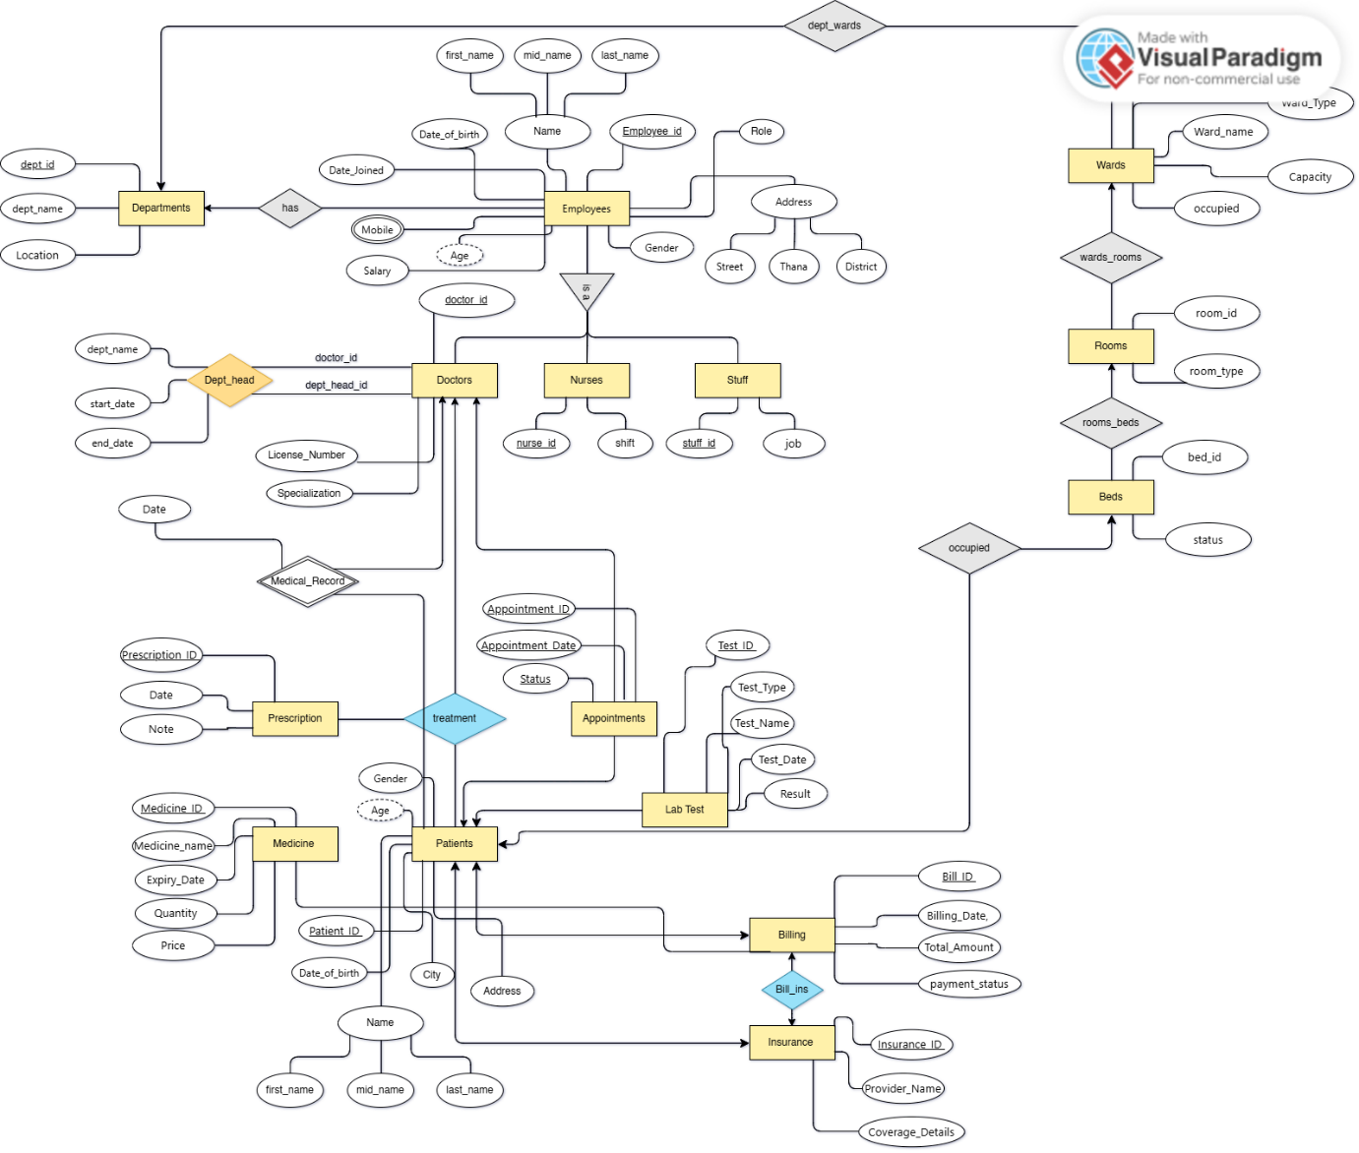

* **Relation Schemas**

Departments (dept_id(PK) , dept_name, location)

Employees (employee_id(PK), first_name, mid_name, last_name, date_joined, street, thana, city, district, salary, gender, date_of_birth, role, dept_id(FK))

Employees _mobile (employee_id(PK), mobile)

Employees _email (employee_id(PK), email)

Doctors ( doctor_id(PK), license_number, specialization, employee_id(FK))

Nurses ( nurse_id(PK), shift, employee_id(FK))

Admin (admin_id(PK), job, employee_id(FK))

Patients (patient_id(PK) , name, date_of_birth, gender, city, phone)

Wards (ward_id(PK), ward_name, ward_type, floor, capacity, occupied, dept_id(FK))

Rooms (room_id(PK), room_number, room_type, ward_id(FK))

Beds (bed_id(PK), bed_status(Occupied/Available), room_id(FK), patient_id(FK))

Appointments (appointment_id(PK), appointment_date, status(Scheduled/Completed/Cancelled), patient_id, doctor_id(FK))

Lab Test (test_id(PK), test_name, test_type, test_date, result, patient_id(FK))

Prescription (prescription_id(PK), date, notes, patient_id, doctor_id)

Treatment (treatment_id(PK), treatment_description, start_date, end_date, patient_id(FK), doctor_id(FK), prescription_id(FK))

Medicine (medicine_id(PK), medicine_name, expiry_date, quantity, price)

Billing (bill_id(PK), total_amount, billing_date, payment_status (Paid/Unpaid), patient_id(FK))

Insurance (insurance_id(PK), provider_name, coverage_details, patient_id(FK), bill_id(FK))

Department_head ((dept_head_id(FK),doctor_id(FK) ,dept_id(FK))(PK), start_date, end_date)

Medical Record (doctor_id(FK), patient_id(FK) , date)

* **SQL DDL for the Relation Schema**

-- Database: `hospital_mgmt`

-- Table structure for table `users`

CREATE TABLE users (

id INT AUTO_INCREMENT PRIMARY KEY,

name VARCHAR(100) NOT NULL,

email VARCHAR(255) NOT NULL UNIQUE,

password VARCHAR(255) NOT NULL,

role ENUM('Doctor', 'Nurse', 'Staff', 'Admin')

);

-- Table structure for table `beds`

CREATE TABLE `beds` (

`bed_id` int(11) NOT NULL,

`bed_status` enum('Occupied','Available') DEFAULT 'Available',

`room_id` int(11) DEFAULT NULL,

`patient_id` int(11) DEFAULT NULL

)

-- Table structure for table `billing`

CREATE TABLE `billing` (

`bill_id` int(11) NOT NULL,

`total_amount` decimal(10,2) NOT NULL,

`billing_date` date NOT NULL,

`payment_status` enum('Paid','Unpaid') NOT NULL,

`patient_id` int(11) DEFAULT NULL

)

-- Table structure for table `departments`

CREATE TABLE `departments` (

`dept_id` int(11) NOT NULL,

`dept_name` varchar(100) DEFAULT NULL,

`location` varchar(100) DEFAULT NULL,

`dept_head` varchar(100) DEFAULT NULL

)

-- Table structure for table `employees`

CREATE TABLE `employees` (

`employee_id` int(11) NOT NULL,

`first_name` varchar(50) DEFAULT NULL,

`mid_name` varchar(50) DEFAULT NULL,

`last_name` varchar(50) DEFAULT NULL,

`mobile` varchar(15) DEFAULT NULL,

`date_joined` date DEFAULT NULL,

`street` varchar(100) DEFAULT NULL,

`thana` varchar(50) DEFAULT NULL,

`city` varchar(50) DEFAULT NULL,

`district` varchar(50) DEFAULT NULL,

`salary` decimal(10,2) DEFAULT NULL,

`gender` varchar(10) DEFAULT NULL,

`date_of_birth` date DEFAULT NULL,

`dept_id` int(11) DEFAULT NULL,

`roll` enum('Doctor','Nurse','Staff') NOT NULL,

`license_number` varchar(255) DEFAULT NULL,

`specialization` varchar(255) DEFAULT NULL,

`shift` varchar(50) DEFAULT NULL,

`staff_role` varchar(50) DEFAULT NULL

)

-- Table structure for table `insurance`

CREATE TABLE `insurance` (

`insurance_id` int(11) NOT NULL,

`provider_name` varchar(255) NOT NULL,

`coverage_details` text DEFAULT NULL,

`patient_id` int(11) DEFAULT NULL,

`bill_id` int(11) DEFAULT NULL

)

-- Table structure for table `medicine`

CREATE TABLE `medicine` (

`medicine_id` int(11) NOT NULL,

`medicine_name` varchar(100) NOT NULL,

`expiry_date` date DEFAULT NULL,

`quantity` int(11) NOT NULL,

`price` decimal(10,2) NOT NULL

)

-- Table structure for table `patients`

CREATE TABLE `patients` (

`patient_id` int(11) NOT NULL,

`name` varchar(100) DEFAULT NULL,

`date_of_birth` date DEFAULT NULL,

`gender` varchar(10) DEFAULT NULL,

`city` varchar(50) DEFAULT NULL,

`phone` varchar(15) DEFAULT NULL

)

-- Table structure for table `rooms`

CREATE TABLE `rooms` (

`room_id` int(11) NOT NULL,

`room_number` varchar(20) DEFAULT NULL,

`room_type` varchar(50) DEFAULT NULL,

`ward_id` int(11) DEFAULT NULL

)

-- Table structure for table `wards`

CREATE TABLE `wards` (

`ward_id` int(11) NOT NULL,

`ward_name` varchar(100) DEFAULT NULL,

`ward_type` varchar(50) DEFAULT NULL,

`floor` int(11) DEFAULT NULL,

`capacity` int(11) DEFAULT NULL,

`occupied` int(11) DEFAULT 0,

`department_id` int(11) DEFAULT NULL

)

-- Table structure for table `appointments`

CREATE TABLE `appointments` (

`appointment_id` int(11) NOT NULL,

`appointment_date` date NOT NULL,

`status` enum('Scheduled','Completed','Cancelled') DEFAULT NULL,

`patient_id` int(11) DEFAULT NULL,

`doctor_id` int(11) DEFAULT NULL

)

-- Table structure for table `department_head`

CREATE TABLE `department_head` (

`dept_head_id` int(11) NOT NULL,

`doctor_id` int(11) NOT NULL,

`dept_id` int(11) NOT NULL,

`start_date` date DEFAULT NULL,

`end_date` date DEFAULT NULL

)

-- Table structure for table `doctors`

CREATE TABLE `doctors` (

`doctor_id` int(11) NOT NULL,

`license_number` varchar(50) NOT NULL,

`specialization` varchar(100) DEFAULT NULL,

`employee_id` int(11) DEFAULT NULL

)

-- Table structure for table `nurses`

CREATE TABLE `nurses` (

`nurse_id` int(11) NOT NULL,

`shift` varchar(50) DEFAULT NULL,

`employee_id` int(11) DEFAULT NULL

)

-- Table structure for table `lab_test`

CREATE TABLE `lab_test` (

`test_id` int(11) NOT NULL,

`test_name` varchar(100) NOT NULL,

`test_type` varchar(50) DEFAULT NULL,

`test_date` date DEFAULT NULL,

`result` varchar(255) DEFAULT NULL,

`patient_id` int(11) DEFAULT NULL

)

-- Table structure for table `prescription`

CREATE TABLE `prescription` (

`prescription_id` int(11) NOT NULL,

`date` date NOT NULL,

`notes` text DEFAULT NULL,

`patient_id` int(11) DEFAULT NULL,

`doctor_id` int(11) DEFAULT NULL

)

-- Table structure for table `treatment`

CREATE TABLE `treatment` (

`treatment_id` int(11) NOT NULL,

`treatment_description` text NOT NULL,

`start_date` date DEFAULT NULL,

`end_date` date DEFAULT NULL,

`patient_id` int(11) DEFAULT NULL,

`doctor_id` int(11) DEFAULT NULL,

`prescription_id` int(11) DEFAULT NULL

)

* **The screenshots of UI of the implemented project**

Home Page

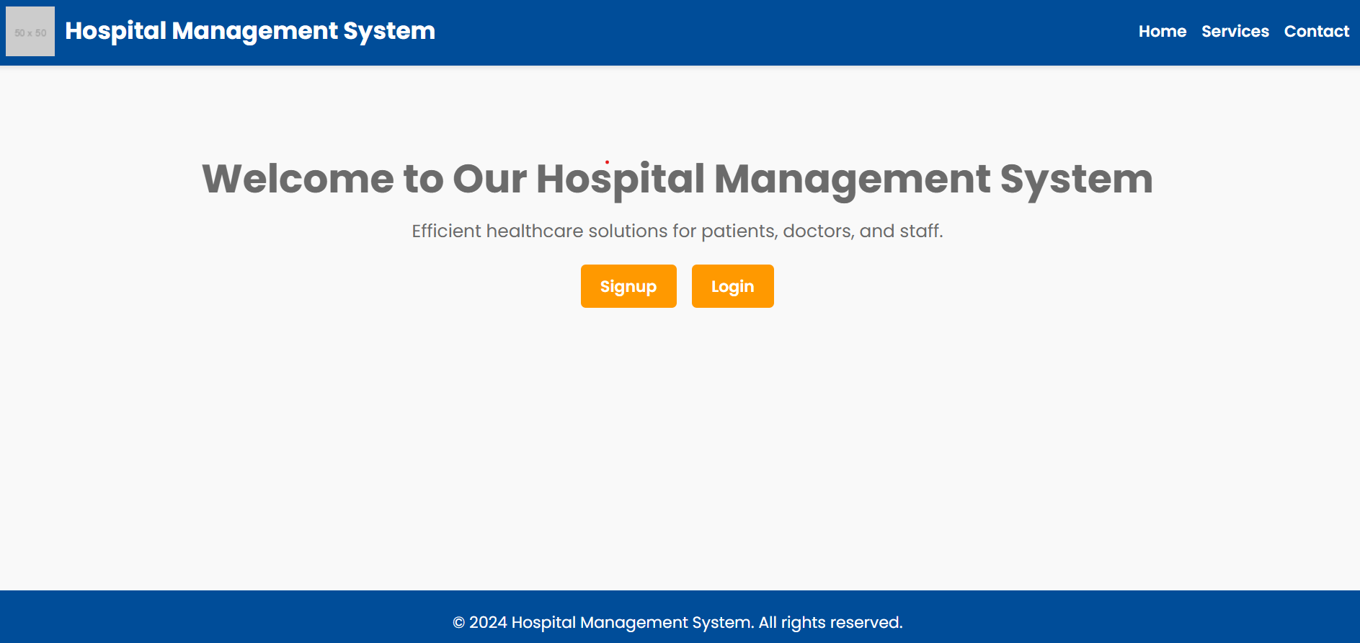

Signup

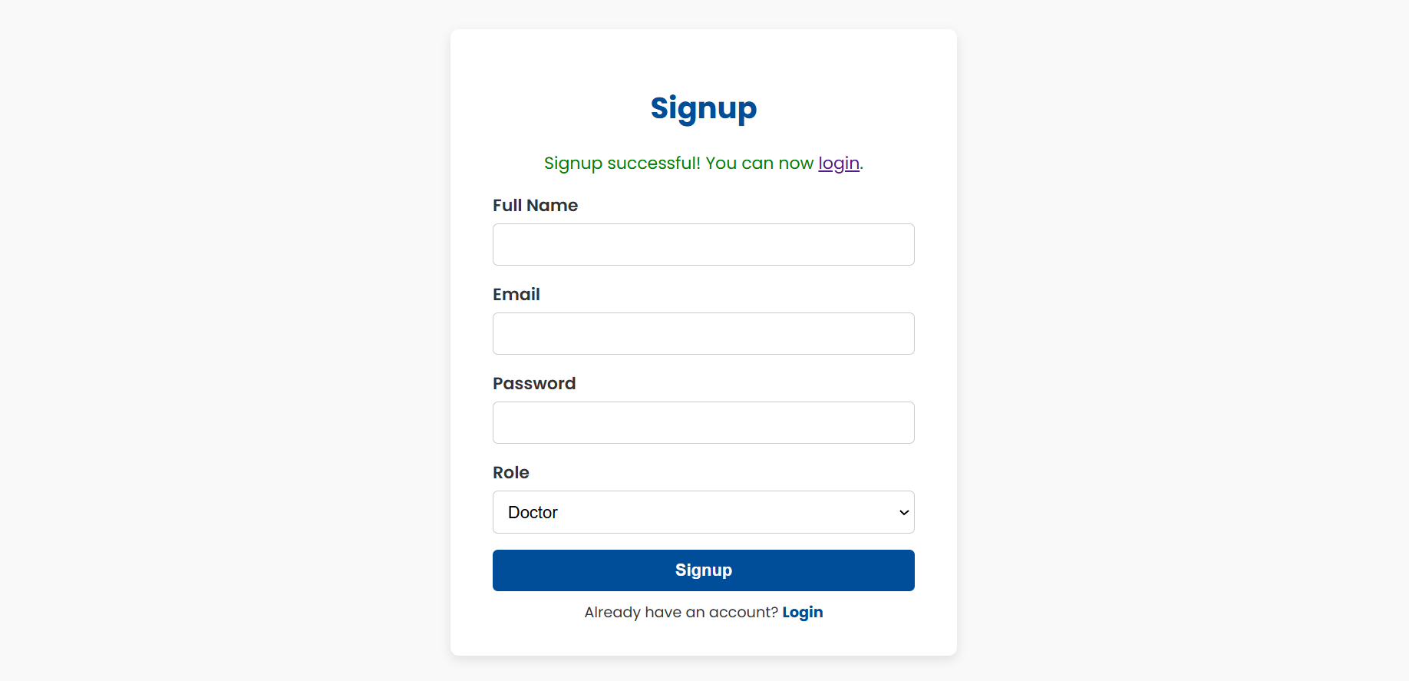

Login

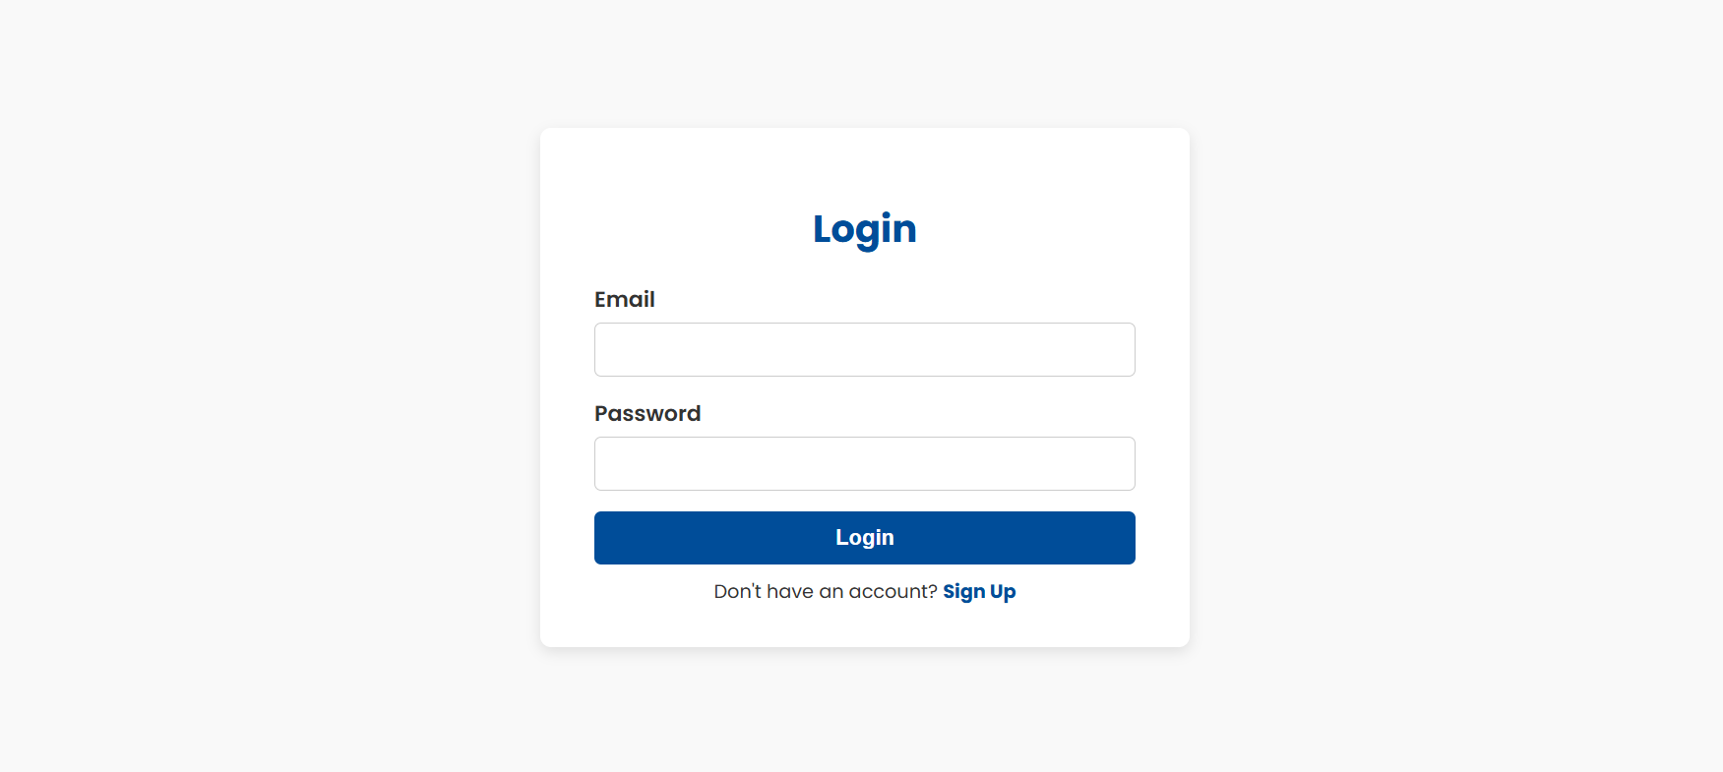

DashBoard

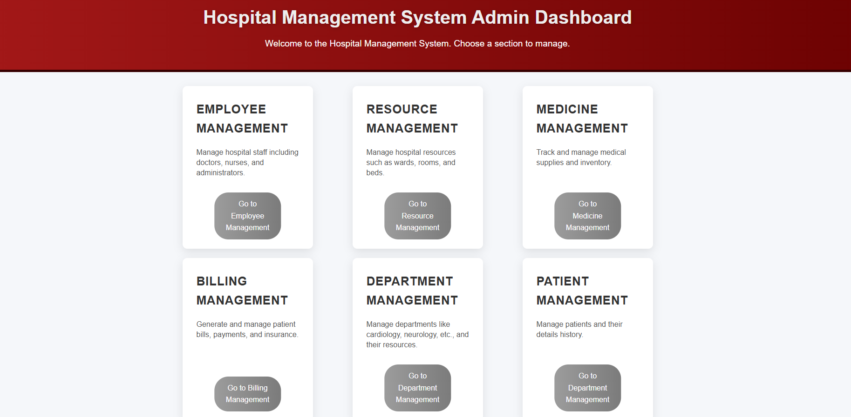

Employee Management

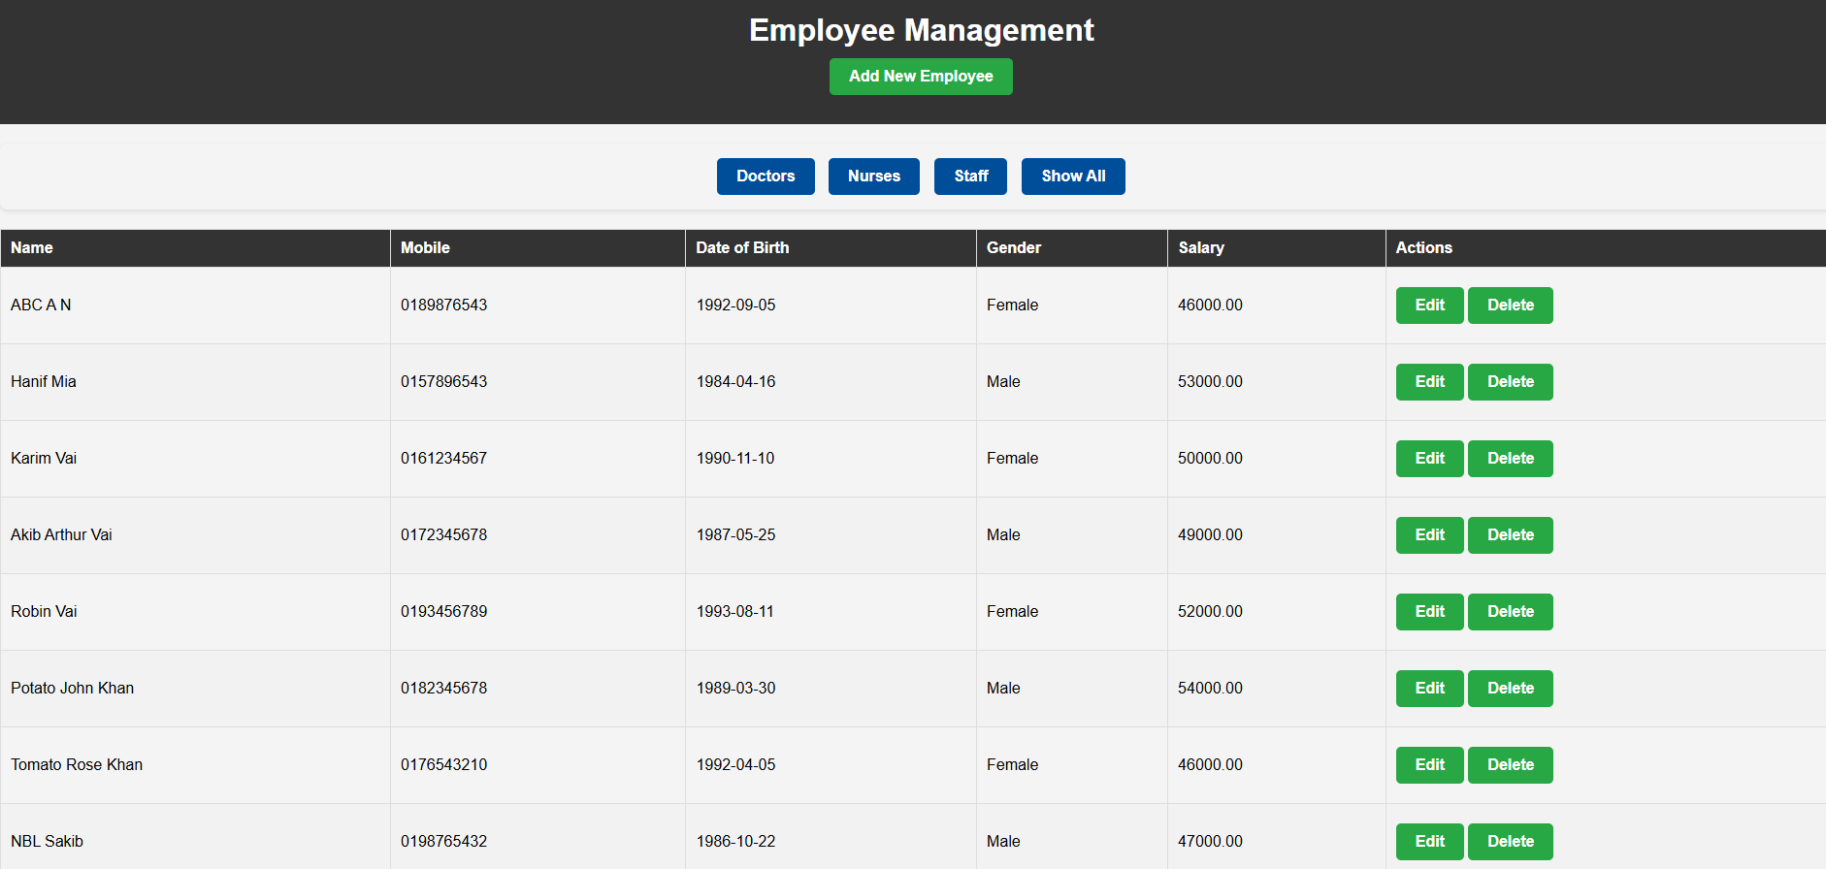

Resource Management

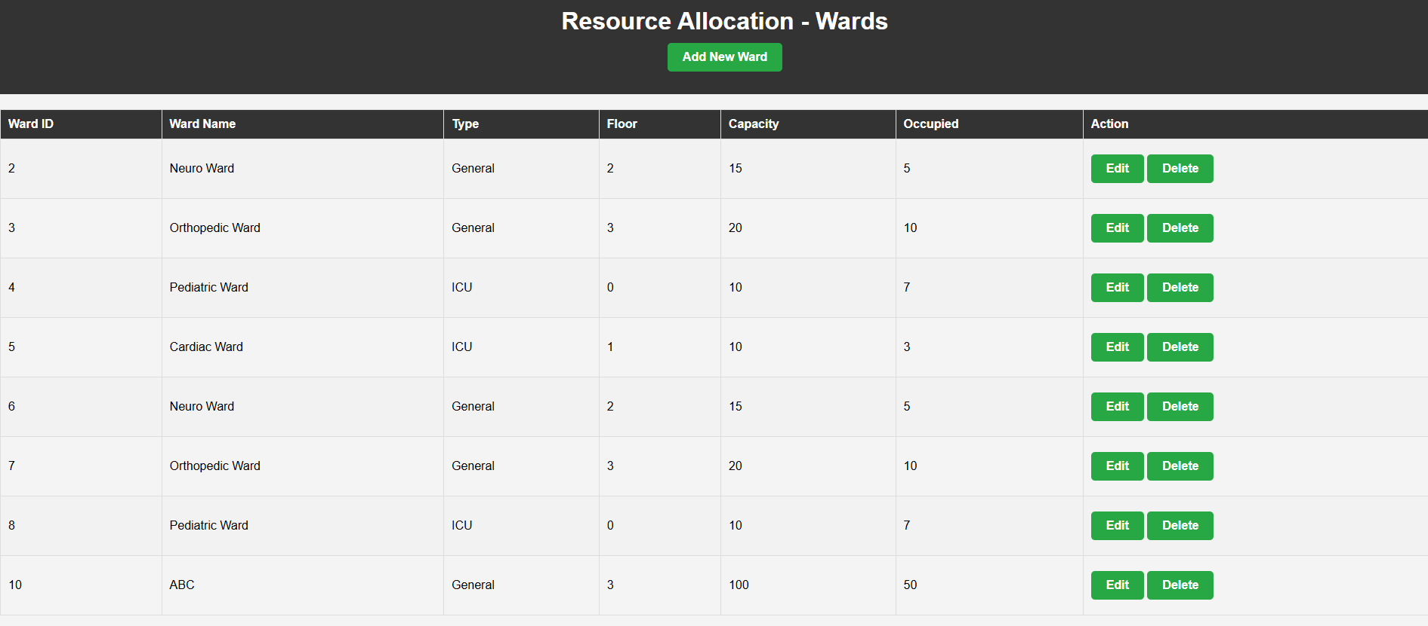

Medicine Management

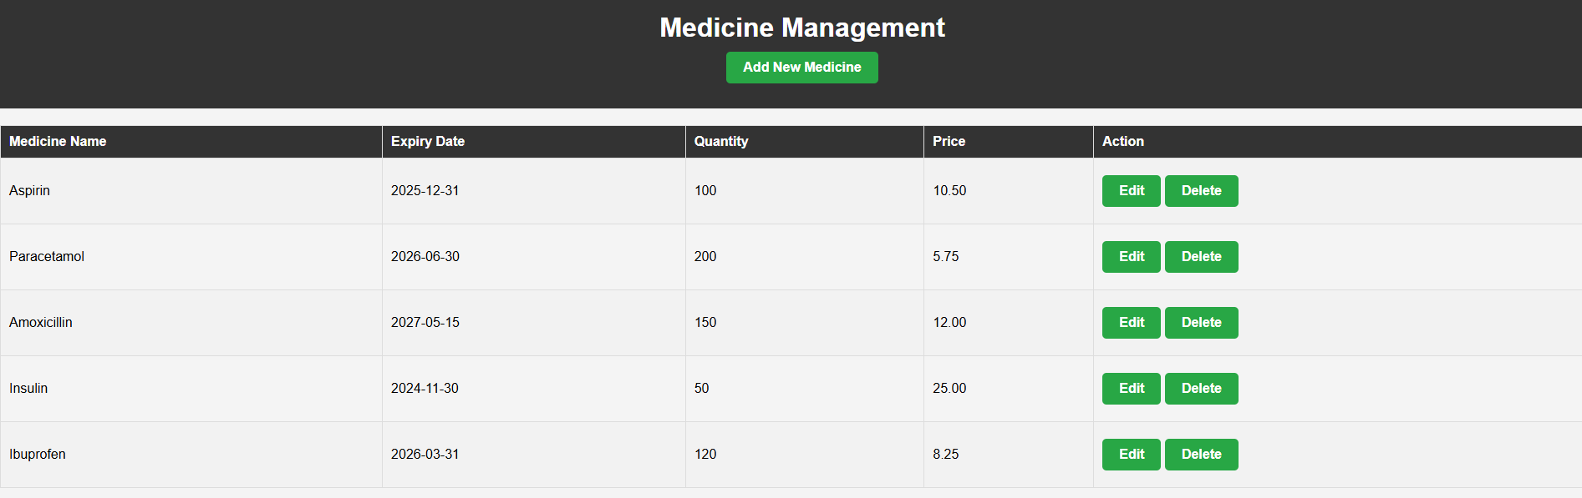

Billing Management

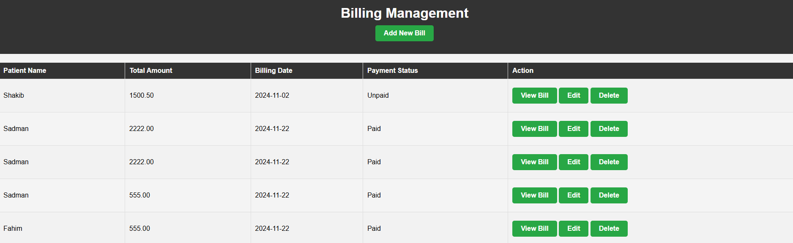

Department Management

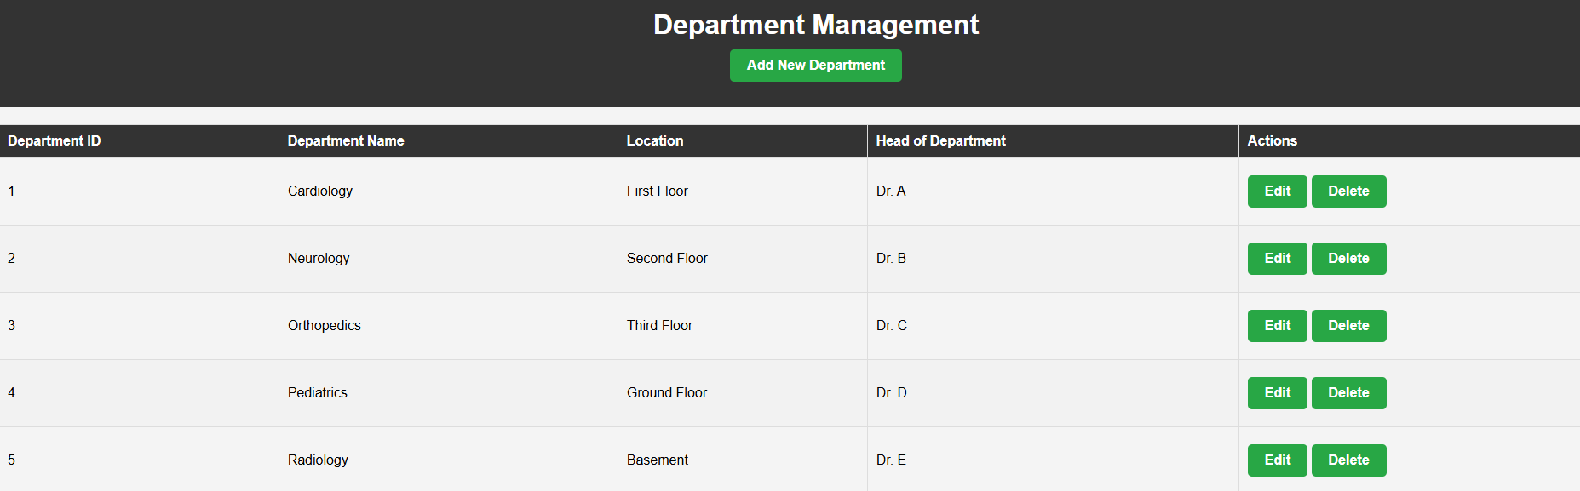

Patient Management

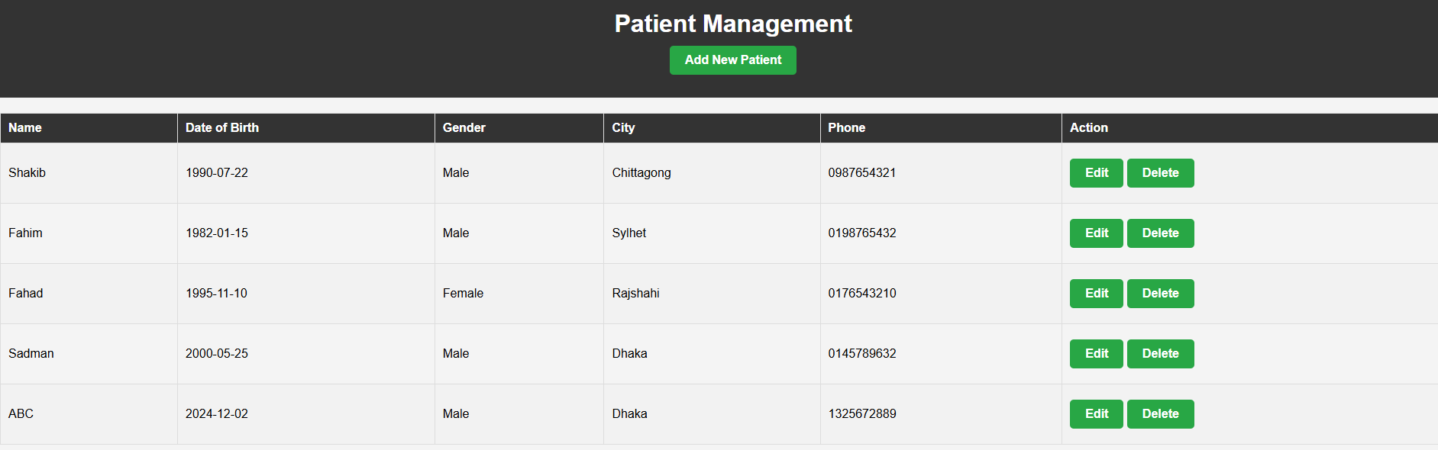

* **Conclusion**

This Hospital Management System (HMS) project demonstrates a comprehensive approach to managing hospital operations and patient care. By leveraging an entity-relationship model and relational schema, the system ensures seamless integration of departments, employees, patients, and medical services.

The carefully designed database structure allows for robust data integrity and consistency, while accommodating the dynamic needs of a hospital environment. From tracking patient appointments and medical records to managing ward occupancy and financial transactions, the HMS provides an efficient and scalable solution for hospital management.

Our implementation emphasizes data accuracy, efficient resource allocation, and user-friendly interfaces, ensuring that hospital administrators, medical staff, and patients benefit from streamlined operations. This project serves as a foundational framework for further enhancements, such as integrating advanced analytics, real-time monitoring, and automated decision-making systems to address future challenges in healthcare management.